Project Information Report - Godrej Lakeside

Orchard

Project Summary
Sales Status: Sustenance
Construction Status: Under Construction, 7th /12th floor

Configurations (all of them) & Pricing (in crs.)
Configuration | Saleable Area/SBU Size (sq. ft.) | Pricing Range (Agreement Value) | Pricing Range  (Agreement Value + GST) | Pricing Range (Agreement Value + GST + SDR)
3 BHK Luxe | 1790-2260 sq. ft. | 2.37 Cr. | 2.37 Cr. + 5 % | 2.37 Cr. + 5 % + 7.7%
3.5BHK Luxe | 2214-2257 sq. ft. | 2.75 Cr. | 2.75 Cr. + 5 % | 2.75 Cr. + 5 % + 7.7%

RERA: Possession & OC Timelines
  - RERA Number: PRM/KA/RERA/1251/446/PR/300924/007105
  - RERA Certificate Link: PRM/KA/RERA/1251/446/PR/300924/007105
  - Possession Timeline As Per RERA (Month and Year): 30-09-2030
  - Possession Timeline Target As Per GPL (Month and Year):07-2028

Freedom Payment Plan
- Payment Plan - 20:80 Payment Plan
- How it will work for this project (with demo illustration of the calculation):

3BHK Luxe Sample Calculation Total Cost for Customer 2,51,69,211
Total Agreement Value 2,37,03,097

Milestone - 20:80 Payment Plan | % | 3bhk Luxe-1790sqft | Logic
Booking Amount | 5% | 12,44,412.59 | 5% Of Agreement Value + additional 5% GST of that value
Within 21 days of Booking | 5% | 12,44,412.59 | 5% Of Agreement Value + additional 5% GST of that value
Within 60 days of Booking | 10% | 24,88,825.18 | 10% Of Agreement Value +  additional 5% GST of that value
On Application of OC | 70% | 1,74,21,776.29 | 70% Of Agreement Value +  additional 5% GST of that value
On Notice of Possession | 10% | 24,88,825.18 | 10% Of Agreement Value +  additional 5% GST of that value
On Notice of Possession: Advance Maintenance & Sinking Fund Charges | 0% | 2,80,959.67 | Advanced Maintenance & Sinking Fund Charges + 18% GST of Advanced Maintenance Value
Total Cost | 100% | 2,51,69,211

Additional SDR Charges of 7.7% at the time of possession

* This illustration is for representation purposes only. The actual calculation and monthly payout may vary depending on the (i) unit selected (ii) associated charges for that unit and (iii) the offers available at project marketing office.

Floor Plans

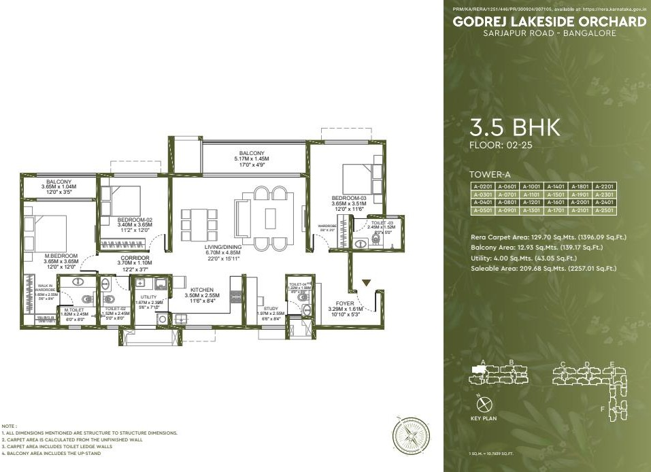

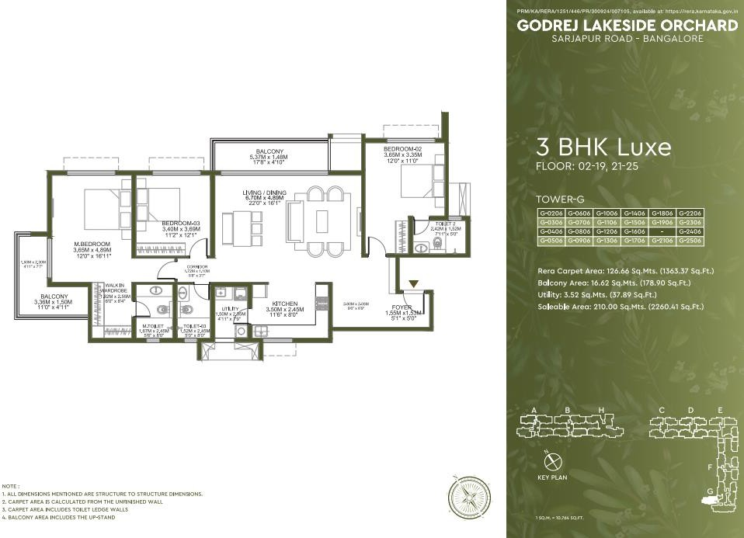

Location Advantages
🚗 Connectivity
  - Outer Ring Road- 15 min*
  - Marathahalli – 30–35 min*
  - Bellandur – 26min*
  - Electronic City – 30–35 min*
  - S.H. 35- 12min*

🚉 Commute & Transport
  - Proposed Iblur Metro Station- 15 min*
  - Proposed Carmelaram Metro Station- 6 min*
  - Carmelaram Railway Station- 7min*

🛍️ Recreational & Lifestyle Hubs
  - DoubleTree Suites by Hilton Hotel - 13 min*
  - Rural Blues- 8min*
  - Fair eld by Mariott- 16min*
  - Soul Space Spirit Centro Mall- 15min*
  - Bier Library- 8 min*
  - Byg Brewski - 10 min*

💼 Tech Parks & Employment Hubs
  - Global Technology Park - 16 min*
  - RGA Tech Park – 6min*
  - Cessna Business Park- 20min*
  - RMZ Ecospace- 15min*
  - Embassy Tech Village – 20min*
  - Wipro – 8min*

➵ Schools & Colleges
- CMR Gandhi Public School – 4min*
- DPS EAST -8min*
- Harvest International School -15min*
- Primus Public School -12min*
- Inventure Academy – 14min*
- Oakridge International School – 13min*
- GEAR Innovative International School -14min*
- The International School -14min*

🏥 Healthcare Facilities
  - Belenus Champion Hospital – 7 min*
  - Natus Women & Children Hospital – 7min*
  - Motherhood Hospital – 11min*
  - Cloud nine Hospital -10min*
  - Sakra World Hospital- 18min*
  - Manipal Hospital -15min*

Micro Marketing Understanding
📍 Market Overview
Sarjapur has emerged as one of Bengaluru’s fastest-growing residential and IT Hubs, driven by its strategic connectivity to Whitefield, Electronic City, Outer Ring Road (ORR) and Bellandur. With the presence of leading IT parks, reputed international schools and world-class social infrastructure, the location continues to attract both end-users and long-term investors. Ongoing infrastructure developments, including the Peripheral Ring Road
(PRR), Satellite Town Ring Road (STRR), the proposed Metro connectivity, are expected to further enhance accessibility and support sustained property value appreciation.

📈 Growth Story
The growth of Sarjapur is anchored on three key pillars:
- IT & Employment Hub Advantage

*With Outer Ring Road (ORR), Whitefield, Electronic City and Bellandur emerging as Bengaluru’s largest IT corridors:
  - Strong demand from IT professionals working in nearby tech parks.

  - Excellent connectivity to major employment hubs within 20–40 minutes*

  - High demand for both end-use and rental housing.

👉 This creates a strong and sustainable residential demand pipeline.

- Infrastructure-Led Growth

  - Proposed Metro connectivity, Peripheral Ring Road (PRR), and Satellite Town Ring Road (STRR) will significantly improve accessibility.

  - Continuous road upgrades are reducing travel time across East Bengaluru.

  - Improved infrastructure is expected to drive long-term capital appreciation.

👉 This enhances connectivity and boosts future property values.

- Premium Social Infrastructure

  - Home to reputed international schools, hospitals, retail hubs, and lifestyle destinations.
  - Well-developed social infrastructure makes Sarjapur ideal for families and professionals.
  - Presence of premium residential communities continues to attract quality end-users.
👉 This positions Sarjapur as one of Bengaluru’s most preferred residential destinations.

💰 Price Positioning Advantage
- Sarjapur offers strong appreciation potential driven by IT growth and infrastructure development.
- Provides a wide range of premium apartments and villas across different budget segments.
- Preferred by IT professionals, first-time homebuyers, and upgrade seekers due to its excellent connectivity and lifestyle ecosystem.

👉 Positioned as:
A high-growth residential corridor with strong end-user demand and long-term investment potential.

👥 Buyer Profile
- IT professionals working in Outer Ring Road (ORR), Electronic City, Whitefield, Bellandur, and Marathahalli.
- First-time homebuyers and young salaried professionals.
- Mid-to-senior management executives seeking premium lifestyle homes.
- NRIs and long-term investors looking for capital appreciation and rental income.
- Families preferring reputed international schools, healthcare, and modern social infrastructure.

🏗️ Developer Activity & Market Maturity
- Strong presence of branded developers such as Godrej Properties, Prestige Group, Sobha, Assetz, Birla Estates, Nambiar Builders, and Puravankara.

- Rapid growth of premium integrated townships and high-rise residential communities catering to end-users and investors.
- Well-established social infrastructure with reputed international schools, hospitals, retail malls, and commercial hubs, making Sarjapur one of Bengaluru’s most mature residential markets.

👉 A well-established, high-growth residential corridor backed by strong developer confidence and robust infrastructure.

⚖️ Competitive Landscape
Compared to Whitefield:

  - Better connectivity to the Sarjapur–ORR IT corridor

  - Lower inventory levels, supporting stronger price appreciation

  - Preferred by IT professionals working along ORR and Sarjapur Road

Compared to Electronic City:

  - Superior social infrastructure with reputed schools, hospitals, and retail

  - Better access to major IT hubs such as ORR, Bellandur, and Marathahalli

  - Stronger demand from both end-users and investors, driving higher appreciation potential

FAQs Used By Sales & Pre-Sales Teams
General Project FAQs

  - Where exactly is the project located?

Godrej Lakeside Orchard is in Sarjapur, East Bangalore, next to RGA Tech park, offering easy access to major IT hubs.
  - Who is the developer?

The project is developed by Godrej Properties, one of India’s most trusted real estate brands.

  - Is the project RERA approved?

Yes

  - What is the possession timeline?

September 2030

  - What configurations are available?

3 BHK Luxe & 3.5 BHK

Pricing & Costing FAQs

  - What is the starting price?

2.37 cr. on wards

- What are the additional charges?

GST, PLC, FRC, AM, SDR

Are there any hidden costs?

No there are no hidden charges

20:80 Freedom Payment Plan FAQs

- What is the 20:80 Freedom payment plan?

20:80 Freedom Payment Plan - pay just 20% now, the remaining 80% on possession.

- Does the 20:80 freedom payment plan include GST and registration?

20:80 yes it’s include GST and Exclude Registration.

- How much do I need to pay upfront?

10 percent of property value.

- When does the home loan EMI start?

After 10 percent of initial payment home loan can start.

- Can I prepay or exit the 20:80 freedom payment plan?

No

Location & Connectivity FAQs

- How far is Whitefield?

45 min from Whitefield

- Is metro connectivity available?

Yes, its available

- How far is the airport?

2 hours from airport

Investment & Decision-Making FAQs

- Is this a good investment?

Yes, due to:

- Proximity to IT Hubs
- Upcoming metro expansion

- Who is this project ideal for?

  - IT professionals working in the Outer Ring Road (ORR), Sarjapur Road, Electronic City, and Whitefield corridors
  - Families looking for a well-connected location with premium schools, hospitals, and everyday conveniences
  - End-users seeking a balanced lifestyle with excellent connectivity and social infrastructure
  - Investors looking for strong long-term capital appreciation and rental demand in one of Bengaluru's fastest-growing micro-markets
  - Homebuyers seeking premium residential communities in a high-growth IT corridor

Construction & Quality FAQs

- What is the current construction status?

Under Construction, 7th/12th floor.

Conflict Handling FAQs

- Why should I buy in Sarjapur instead of Whitefield?

Sarjapur offers stronger long-term appreciation potential, excellent connectivity to major IT hubs, and a well-developed social infrastructure with relatively lower traffic congestion than Whitefield.
- What if the project gets delayed?

Being a reputed developer, delays are rare—and RERA ensures accountability and compensation clauses.

- Is the 20:80 freedom payment plan really beneficial?

Yes, it reduces financial burden during construction and improves cash flow flexibility.

Closing-Oriented FAQs

- What is the best unit available now?

Premium-facing units (Lake view / corner units) are currently in high demand and offer better long-term value.

- Are there any current offers?

20:80 freedom payment plan

- How do I block a unit?

Booking amount of 10 percent

Legal Disclaimers

RERA Registered. RERA No. PRM/KA/RERA/1251/446/PR/300924/007105 Project is registered as Godrej Lakeside Orchard, available at website: http://rera.karnataka.gov.in.

Site address: Godrej Lakeside Orchard, Survey Nos. 77, 174/1B, 175/P, 175/2A, 175/2B, 176/2A, 176/2B, 177, 73, 78/1A, 78/2A1(P), 78/2B, 78/3A, 78/4, 79/1C2, 178 of Kodathi Village Varthur Hobli, Bengaluru East, Bengaluru Urban, Karnataka - 560035.

Stock Images for representation purpose only. The images contains artist's impressions. The information is presented as general information and no warranty is expressly or impliedly given that the completed development will comply in any degree with such artist's impression or anticipated appearance. The Sale is subject to terms of Application Form and Agreement for Sale. *The prices mentioned are an indicative Agreement Value, Stamp Duty Registration, GST and Other Charges over and above the Agreement Value. All specifications of the unit shall be as per the final agreement between the Parties. Customers are advised to appraise themselves of the necessary and relevant information of the project(s)/offer(s) prior to making any purchase decision. The official website of Godrej Properties Ltd. is www.godrejproperties.com. Please do not rely on the information provided on any other website. *T&C Apply.

